**Paid Search Bid Optimization and Display Advertising**

## **Question 1 Paid Search Bid Optimization**

**Part A: Estimate the alpha and beta parameters for each of these four keywords Solution**

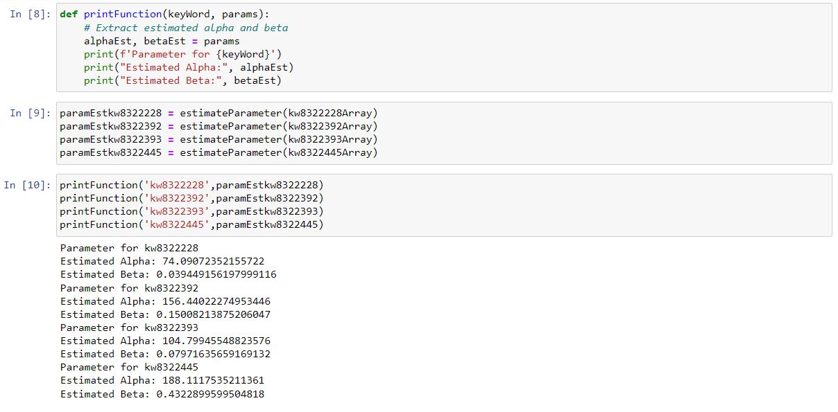

**Part B: Optimal bids for each of the four keywords.**



**Part C: With budget constraint, USD 3000 across 4 key words, optimal bid value, corresponding profit, corresponding total expenditure**

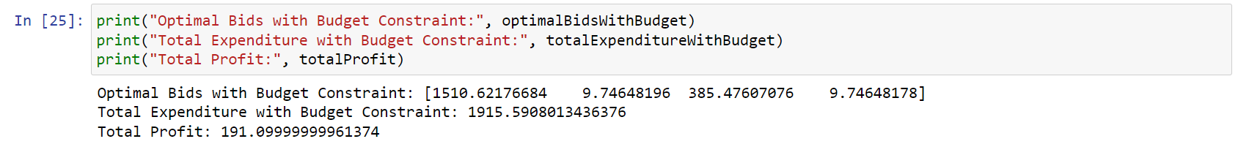

## **Question 2 Display Advertising Assessment**

Question: Assess for each campaign, also of its true expected volume per exposure or impression (abbreviated as "EVI")

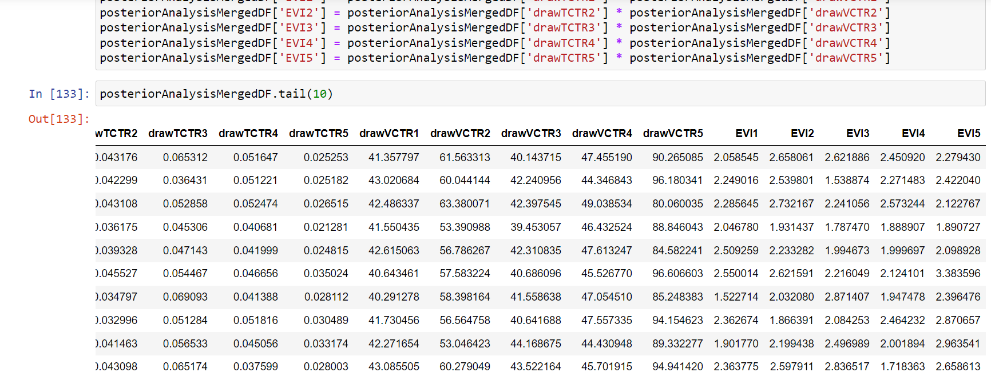

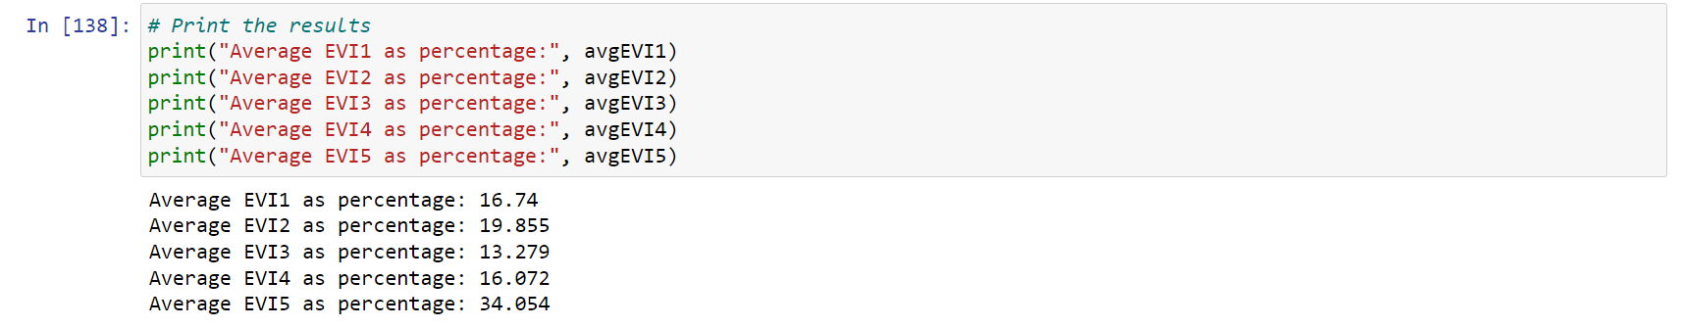

2.1 Compute the Bayesian posterior probability that the campaign's true click-through-rate is the highest across all campaigns.

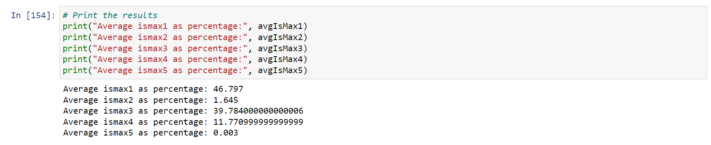

2.2 Compute the Bayesian posterior probability that the campaign's true average post-click volume per click is the highest across all campaigns.

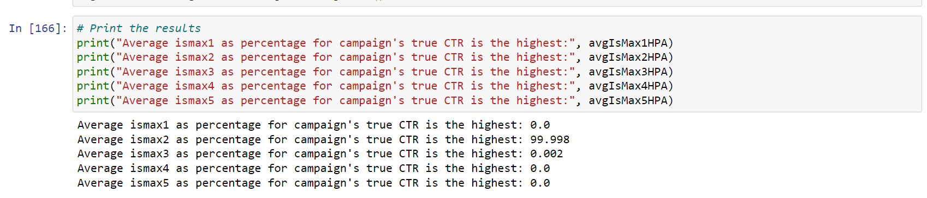

2.3 Compute the Bayesian posterior probability that the campaign's true expected volume per exposure (impression) is the highest.

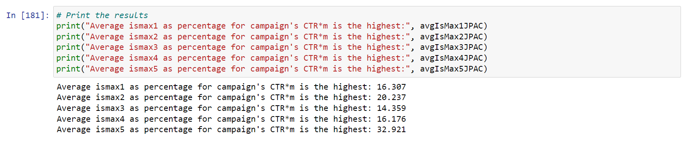

Appendix

|  |  |
| --- | --- |
| **Display Advertising Assessment** |  |
| Task 1: Bayesian posterior probability that a certain campaign's true CTR is the highest |  |
| Task 2: Bayesian posterior probability that a certain campaign's average profit volume is the highest |  |
| Task 3: Bayesian posterior probability that a certain campaign's CTR*m is the highest |  |